

**DevSecOps: Integrating Security in   
DevOps Practices**

**Submitted by: Submitted to:**

Abhinav Rawat Mr. Hitesh Kumar 500120490  
Batch 2 DevOps

**Lab Exercise 1– Install Terraform on Windows**

Installing Terraform on Windows requires you to download the correct Terraform package, unpack, and execute it via the [CLI](https://phoenixnap.com/glossary/common-language-infrastructure). Follow the instructions below to ensure you do not miss any steps.

### Download Terraform File for Windows

To find the latest version of Terraform for Windows:

1. Browse to the [Download Terraform](https://developer.hashicorp.com/terraform/downloads) page.

2. Select the Windows tab under the **Operating System**heading. The latest version is preselected.

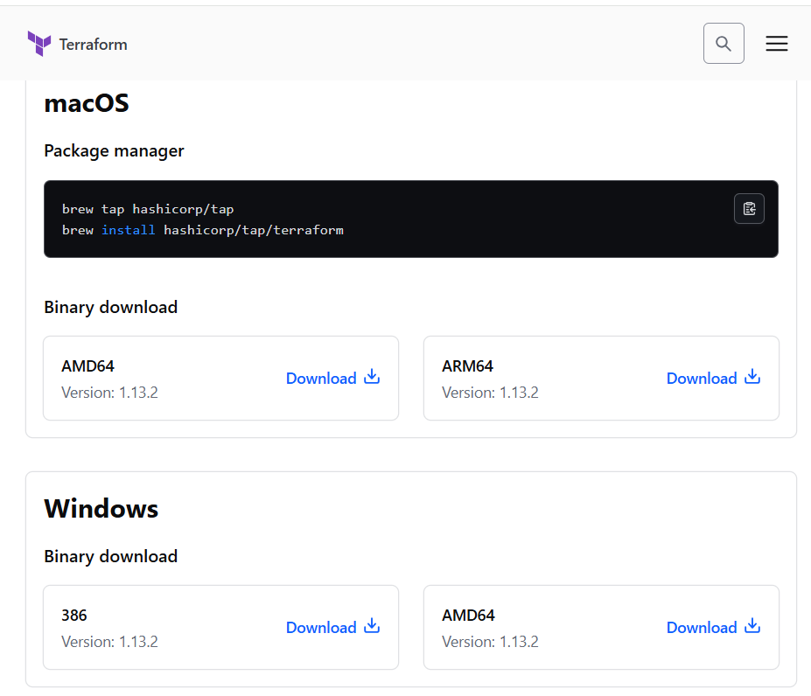

3. Choose the binary to download. Select 386 for 32-bit systems or [AMD64](https://phoenixnap.com/glossary/amd64) for 64-bit systems. Choose the download location for the zip file if the download does not start automatically.

4. Unzip the downloaded file. For example, use the C:\terraform path. Remember this location so you can add the path to the environment variables.

### Add Terraform Path to System Environment Variables

To add the Terraform executable to the system's global path:

1. Open the start menu, start typing environment and click **Edit system environment variables**. The System Properties window opens.

2. Click the **Environment Variables...**button.

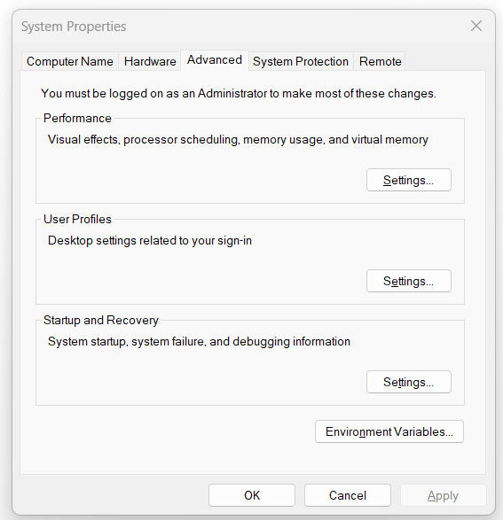

3. Select the **Path variable** in the System variables section to add terraform for all accounts. Alternatively, select **Path**in the **User variables** section to add terraform for the currently logged-in user only. Click **Edit**once you select a Path**.**

4. Click **New**in the edit window and enter the location of the Terraform folder.

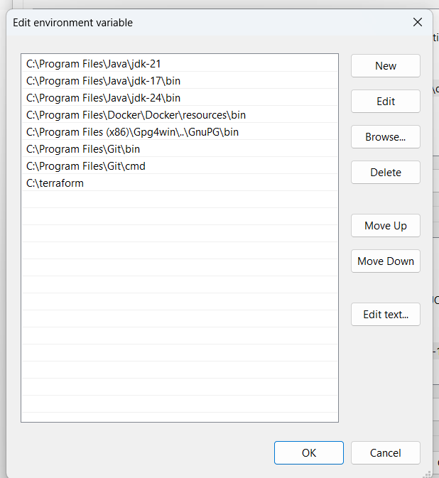

5. Click **OK**on all windows to apply the changes.

### Verify Windows Terraform Installation

To check the Terraform global path configuration:

1. Open a new command-prompt window.

2. Enter the command to check the Terraform version: terraform -version

terraform -version

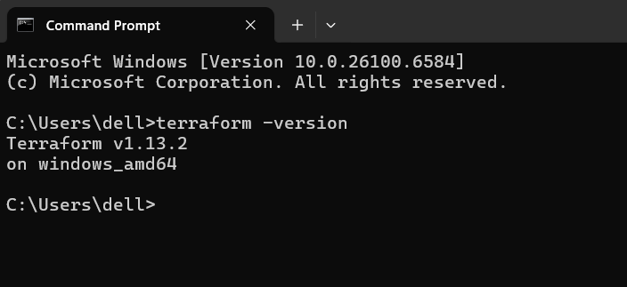

The output shows the Terraform version you downloaded and installed on your Windows machine.